**DAILY ONLINE ACTIVITIES SUMMARY**

|  |  |  |  |  |  |  |  |
| --- | --- | --- | --- | --- | --- | --- | --- |
| **Date:** | **27 may 2020** | | | | **Name:** | **KHATHEEJA SAFREENA** | |
| **Sem & Sec** | **4th sem, 2nd year** | | | | **USN:** | **4AL18CS037** | |
| **Online Test Summary** | | | | | | | |
| **Subject** | | **OBJECT ORIENTED CONCEPTS (18cs45)** | | | | | |
| **Max. Marks** | | **30** | | **Score** | | **24** | |
| **Certification Course Summary** | | | | | | | |
| **Course** | **Introduction to Digital Marketing.** | | | | | | |
| **Certificate Provider** | | | **Great learning** | **Duration** | | | **2.5hours** |
| **Coding Challenges** | | | | | | | |
| **Problem Statement:1 program** | | | | | | | |
| **Status: Executed** | | | | | | | |
| **Uploaded the report in Github** | | | | **Yes** | | | |
| **If yes Repository name** | | | | [http://github.com/shafreenasharief/lockdown-coding](http://github.com/shafreenasharief/lockdown-coding" \o "http://github.com/shafreenasharief/lockdown-coding) | | | |
| **Uploaded the report in slack** | | | | **Yes** | | | |

Online Test Details: (Attach the snapshot and briefly write the report for the same)

Certification Course Details: (Attach the snapshot and briefly write the report for the same)

Coding Challenges Details: (Attach the snapshot and briefly write the report for the same)

**ONLINE TEST SUMMARY:**

Today **OBJECT ORIENTED CONCEPTS (18cs45)** was conducted of first module. Total marks for the test was 30.

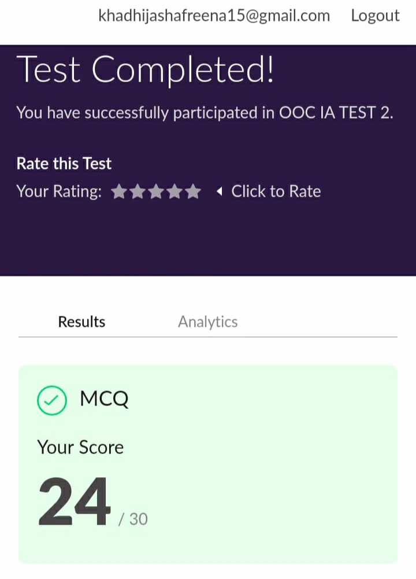

**ONLINE CERTIFICATION COURSE:**

* I'm doing certification course on INTRODUCTION TO DIGITAL MARKETING on great learning.The course is secluded for 2.5 hour.Today I completed 3 module which is Explanation about Introduction to Facebook marketing and Purpose of using Facebook marketing as a channel.I attempted quiz which gave me a clear veiw about the topics that were thought and discussed.
* It consists of 10 modules including assessments.

**CODING CHALLENGES:**

Today I solved 1 coding challenge,

1. **In Bubble sort, each pass consists of comparison each element in the file with its successor (i.e. x[i] with x[i+1]) and interchanging two elements if they are not in the proper order. The array may be sorted in any pass. If the array is sorted, then remaining passes should be skipped off. Write a C Program to sort an array of integers in ascending order and display the sorted array and Number of passes performed for sorting.**

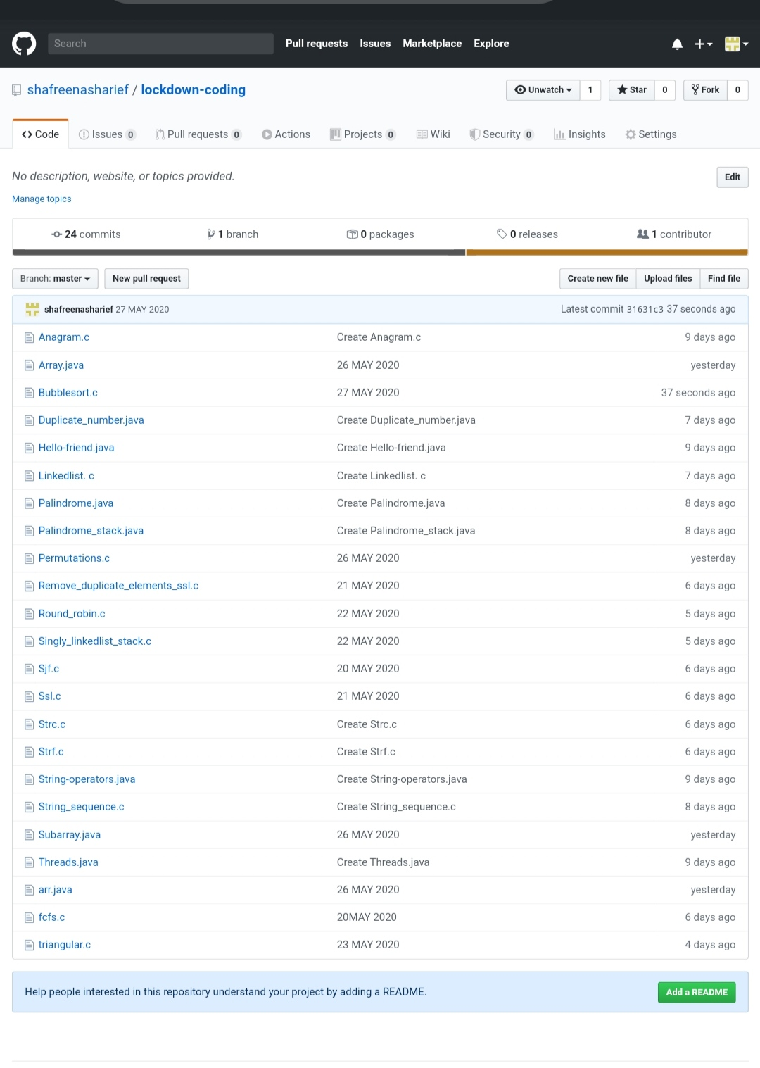

SOLUTION : I have uploaded the solution of the above 4 coding problems in my GitHub repository.

**[https://github.com/shafreenasharief/lockdown-coding](https://github.com/shafreenasharief/lockdown-coding" \o "https://github.com/shafreenasharief/lockdown-coding)**